**Simulation of Intelligent Room Lighting Illuminance Control**

**Methodology:**

Lighting System Design Components:

1. Occupancy sensors

Occupancy sensors are detecting gadgets to empower the control framework to turn OFF the lights when not required.

1. Radar Motion Sensor

This sensor is being used for the system to save energy and to reduce loss in power when there is no movement in indoor environment for a specific time.

1. Window blinds

Window blinds are utilized to give shading. With the assistance of actuators, they can be balanced from an open position to a shut position depending on the measure of a light incident on it.

1. Lux sensors

These are used to sense and measure the amount of light incident in the workplace.

1. Dimming Drivers

They are used to maintain the brightness of artificial lighting sources based on available daylight.

The lighting system Simulink design has been designed and evaluated using the Simulink blocks in MATLAB Simulink environment. Below given figure is a model showing the Simulink design for Intelligent Lighting System.

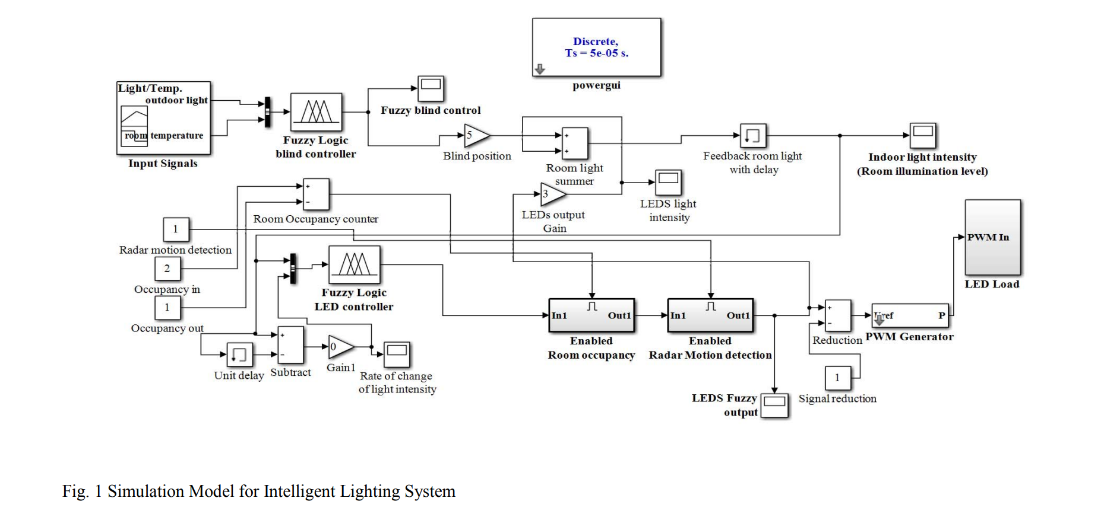

**Result:**

The study presents a novel Simulink model employing fuzzy logic in MATLAB for an energy-efficient lighting system. This model not only ensures adequate illumination levels but also factors in thermal and visual comfort, thus enhancing the overall occupant experience. Furthermore, the integration of automated window blind control adds an extra layer of sophistication to the system, contributing to its energy efficiency and adaptability to changing environmental conditions.

**Conclusion:**

In conclusion, the paper successfully demonstrates the efficacy of fuzzy logic in designing intelligent lighting systems that cater to diverse requirements such as energy efficiency, economic feasibility, and human comfort. The simulation results affirm the system's ability to maintain optimal illumination levels in indoor spaces while minimizing energy consumption. By incorporating advanced control strategies and sensor technologies, the proposed model represents a significant step towards sustainable and smart lighting solutions for the future.